**BLG 435E – Artificial Intelligence**

**2019-2020 Fall, Assignment 2 Report**

**Submission Deadline: 03.12.19, 23:59**

Kadir Emre Oto (150140032)

**Problem 1 – Planning**

**Problem 2 – Decision Tree**

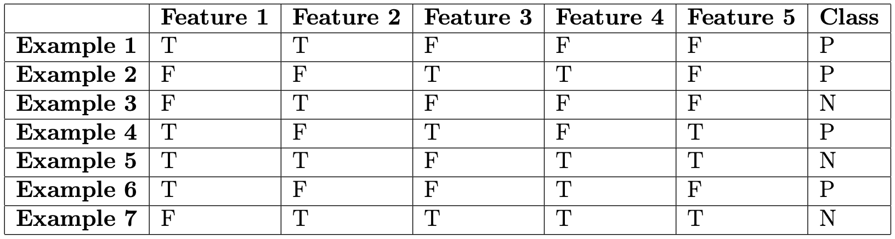You are given the following training set:

1. Construct the decision tree for the given training set, indicating the steps clearly:

For the training set,

$$p=4, n=3$$

$$I\left(4/7,3/7\right)=-4/7*\log_{2}\left(4/7\right)- 3/7*\log_{2}\left(3/7\right)=0.9852$$

Considering the attributes:

$$IG\left(Feature 1\right)=0.9852-\left(4/7*I\left(3/4,1/4\right)+3/7*I\left(1/3,2/3\right)\right)=0.1281$$

$$IG\left(Feature 2\right)=0.9852-\left(4/7*I\left(1/4,3/4\right)+3/7*I\left(3/3,0/3\right)\right)=0.5216$$

$$IG\left(Feature 3\right)=0.9852-\left(3/7*I\left(2/3,1/3\right)+4/7*I\left(1/2, 1/2\right)\right)=0.0202$$

$$IG\left(Feature 4\right)=0.9852-\left(4/7*I\left(1/2,1/2\right)+3/7*I\left(2/3, 1/3\right)\right)=0.0202$$

$$IG\left(Feature 5\right)=0.9852-\left(3/7*I\left(1/3,2/3\right)+4/7*I\left(3/4, 1/4\right)\right)=0.1484$$

Feature 1 has the highest IG, so it is chosen as the root of tree.

1. Using the decision tree you have constructed, classify the following example:

**Problem 3 – Learning Agents**

Answer the following questions:

1. Explain meaning of the terms overfit and underfit.
2. Give one